James Painter

Final Project Milestone 2

**Part 1. Project Overview.**

The Painter_GOLF Database will give hotels a lucrative way of bringing customers to their hotels. Guests can schedule and book everything from the hotel they are staying at. The guests entire bill will be included in their hotel bill making it a one-time pay process when guest check out of their hotel room. Hotels will have to schedule and use their own credit card to reserve the tee times for each Golf Course.

**Part 2. Data Specifications Overview (work in progress).**

The Business Rules are as follows:

* If they cancel the reservation less than 2 weeks in advance they will be charged 25% of the full charge.
* If they cancel the reservation less than 1 week in advance they will be charged 50% of the full charge.
* If they cancel the reservation less than 24 hours or do not show they will be charged full price.
* Some Golf Courses have a dress code. If they have a dress code and they are not wearing appropriate attire they will pay a 20% fee
* If the TeeTimeStartTime and TeeTimeEndTime are less than 3hours there will be a 25% deduction to their bill.

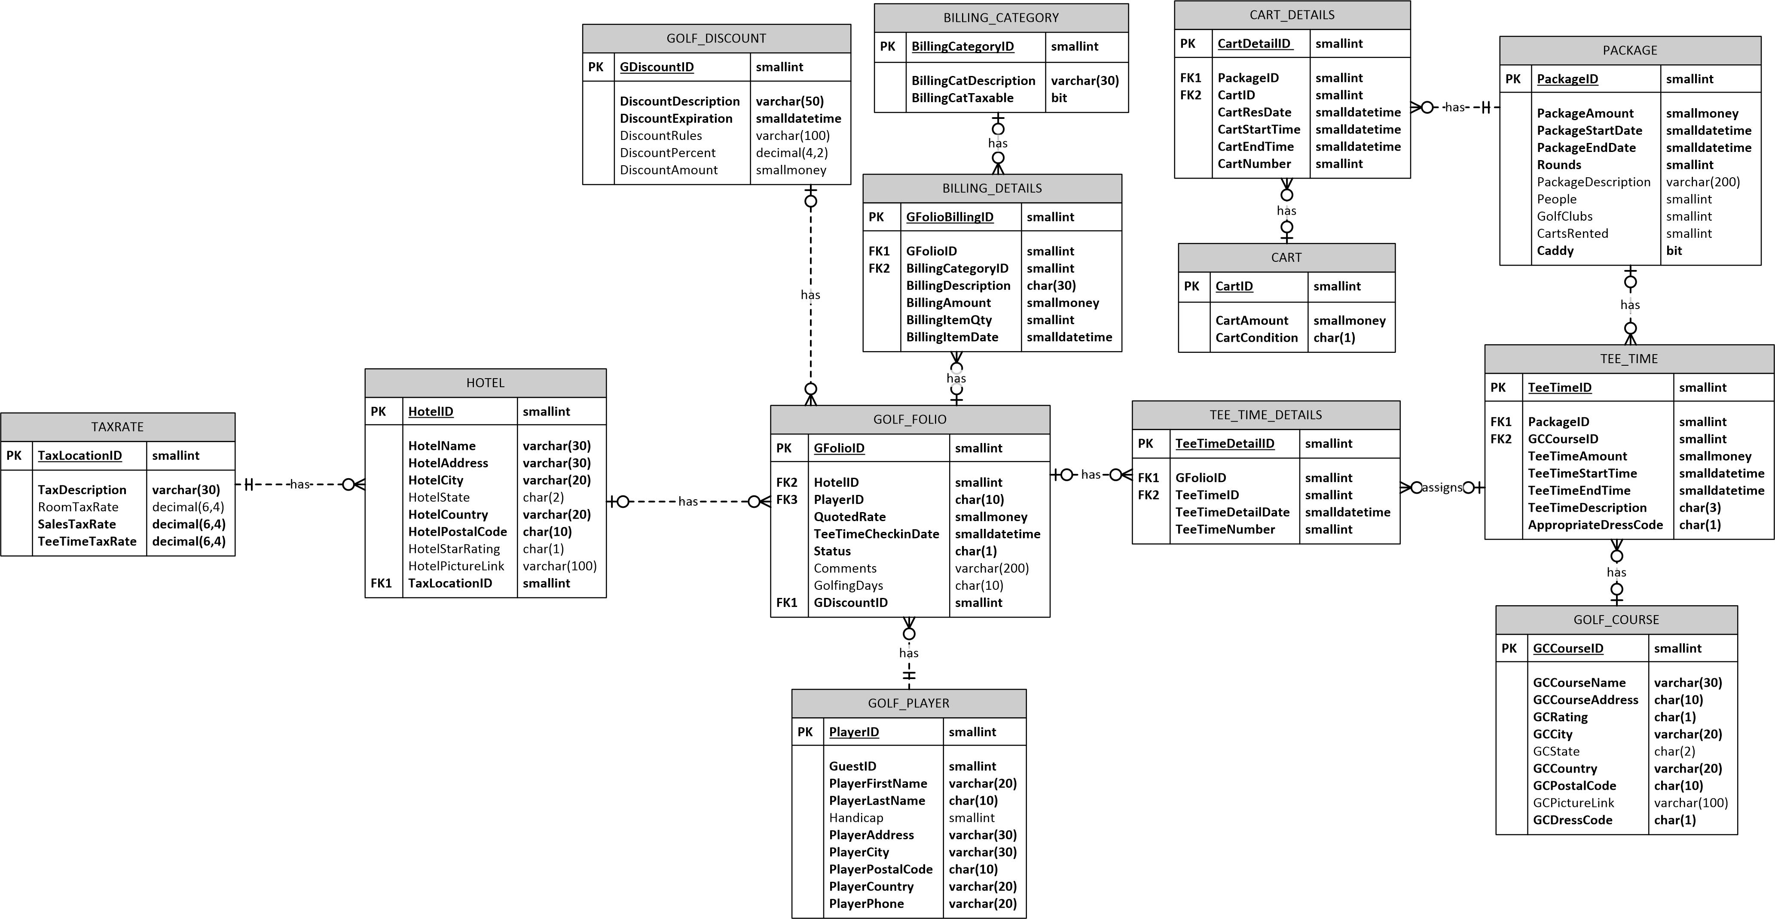

* [**Video Presentation**](Video/FinalProjectPresentation.mp4) **&** [**Painter_GOLF ERD JPG**](DatabaseCreation/Golf.jpg)

**PART A**

**Constraints**

**Primary Key Constraints**

1. PK_GDiscountID
2. PK_GCCourseID
3. PK_BillingCategory
4. PK_TRTaxLocationID
5. PK_HHotelID
6. PK_GFolioID
7. PK_GFolioBillingID
8. PK_TeeTimeID
9. PK_PackageID
10. PK_TeeTimeDetailID
11. PK_CartDetailID
12. PK_CartID
13. PK_PlayerID

**Foreign Key Constraints**

1. FK_HTaxLocationID
2. FK_GFolioID
3. FK_GPGFolioID
4. FK_HotelID
5. FK_GDiscountID
6. FK_GCCourseID
7. FK_TeeTimeDetailID
8. FK_PackageID
9. FK_BDGFolioID
10. FK_BillingCategoryID
11. FK_TTGFolioID
12. FK_CartDetailID
13. FK_CartID

**Check Constraints**

1. GOLF FOLIO - CK_GFStatus
   1. R-being Reserved
   2. D-Drop Reservation
   3. C-Complete
   4. L-being Late
   5. X-No Show
2. TEE TIME - CK_TeeTimeDescription
   1. F9 - Front Nine Holes
   2. B9 - Back Nine Holes
   3. 18 - Full 18 Holes
3. CART – CK_CartCondition
   1. p – poor
   2. f – fair
   3. g – good
   4. e – execellent
4. GOLF COURSE – CK_DressCode
   1. C – Casual
   2. GA – Golf Attire
   3. PA – Professional Attire
5. TEE TIME – CK_TeeTimeDressCode
   1. A – Appropriate Attire
   2. N – Non-Appropriate Attire

**Part B:  List specific BUSINESS RULES Satisfied by TRIGGERS and outlines for each trigger you plan to program**

1. **Trigger Name: tr_PlayerNameLookup**

**Type:**  ON Update/Insert FOR/After

**Detailed Description:** The Trigger tr_PlayerNameLookup will be triggered when an Insert of a player is on the player table that is making a golf reservation. It will call a stored procedure called sp_GuestLookup that will lookup the first and last name in the guest table in the Painter_FARMS Database and see if the guest table has the first and last name of the player being inserted into the player table. If the player’s first and last name is in the guest table then the stored procedure will copy the guest information(GuestAddress1, Guestcity, GuestPostalCode, GuestCountry, GuestPhone) into the player table.

1. **Trigger Name: tr_GFolioStatusChange**

**Type:** ON Update/Insert FOR/After

**Detailed Description:** If the Golf_FOLIO Status changes to C for Complete the trigger will call the stored procedure sp_CreateGolfBill which will go out to the Painter_FARMS database and grab the tax Rate and grab all the different packages, items, and discount amounts and calculate the bill. If the status changes D for Drop Reservation the tr_GFolioStatusChange trigger will call the stored procedure sp_applycharges.

1. **TriggerName: tr_CheckTeeTimeDuration**

**Type:** ON Update/Insert FOR/After

**Detailed Description:** When the TeeTimeEndTime has been inserted or updated the tr_CheckTeeTimeDuration trigger will call the user defined function dbo.ApplyDiscount..

1. **TriggerName: tr_Dresscode**

**Type:** ON Update/Insert FOR/AFTER

**Detailed Description:** When an insert or update happens on the Tee_Time, AppropriateDressCode Column the trigger will check to see if the value is a ‘N’ if the value is ‘N’ then tr_Dresscode will call function called dbo.DressCodeFee which will add a 20% fee of the TeeTime to the TeeTimeAmount.

**Part C:   List specific BUSINESS RULES Satisfied by STORED PROCEDURES and outlines for each SPROC you plan to program**

1. **SPROC NAME:** sp_CreateGolfBill

**Detailed Description:** Will retrieve and calculate a bill based on the GFolioID. The Stored procedure will print the bill with the items being charged. It will use distributed tables to get the taxrate and it will have a cursor that will fetch the items and print them. At the end of the bill will be a total of the bill.

**Input Parameter:** GFolioID

**Output Pararameters:** 0

1. **SPROC NAME:** sp_GuestLookup

**Detailed Description:** This stored procedure will be called from the trigger tr_PlayerNameLookup. sp_GuestLookup will check to see if the first and last name being inserted into the player table correlates with a first and last name in the guest table in the Painter_FARMS database. If it exists copy guest table details to player table. There will be some error handling if the first and last name of the player does not exist. This stored procedure does utilize a linked server and does have impact on the distributed database Painter_FARMS and distributed GUEST table.

**Input Parameters:** @PlayerFirstName, @PlayerLastName

**Output Parameters:** 0

1. **\*SPROC Name:** sp_applycharges

**Detailed Description:** If the trigger tr_GFolioStatusChange calls the sp_applycharges when GOLF_FOLIO Status changes to ‘D’. The stored procedure fees will be applied accordingly depending on when the GFolio Status was changed.

* + If they cancel the reservation less than 2 weeks in advance they will be charged 25% of the full charge.
  + If they cancel the reservation less than 1 week in advance they will be charged 50% of the full charge.
  + If they cancel the reservation less than 24 hours or do not show they will be charged full price.

**Input Parameters:** GFolioID

**Output Parameters:** 0

**Part D:   List specific BUSINESS RULES Satisfied by USER DEFINED FUNCTIONS and outlines for each UDF you plan to program**

1. **UDF NAME:** dbo.ApplyDiscount

**Detailed Description:** dbo.ApplyDiscount will be called when the tee time duration is less than 3 hours. If the duration is less than 3 hours there will be a 20% discount to the GOLF_FOLIO quoted rate.

**Input Parameter:** TeeTimeID

**Returns:** Scalar Value.

1. **UDF NAME:** dbo.DressCodeFee

**Detailed Description:** dbo.DressCodeFee will be called from the tr_DresscodeFee trigger when the TEE_TIME AppropriateDressCode Column has been updated. The dbo.DressCodeFee function will apply a 20% fee of the tee time to the TeeTimeAmount.

**Input Parameter:** TeeTimeID

**Returns:** Scalar Value

1. **UDF NAME:** dbo.GetProducteGolfBill

**Detailed Description:** dbo. ProducteGolfBill is called from sp_CreateGolfBill. The function will return a table called @ProduceGolfBill that will contain all of the data for a particular folio id that is passed in as a parameter

**Input Parameter:** GFolioID

**Returns:** Table

**TRIGGERS**

* [**tr_PlayerNameLookup**](tr_PlayerNameLookup.txt)
* [**tr_GFolioStatusChange**](tr_GFolioStatusChange.txt)
* [**tr_CheckTeeTimeDuration**](tr_CheckTeeTimeDuration.txt)
* [**tr_Dresscode**](tr_Dresscode.txt)

**STORED PROCEDURES**

* [**sp_CreateGolfBill**](sp_CreateGolfBill.txt)
* [**sp_GuestLookup**](sp_GuestLookup.txt)
* [**sp_applycharges**](sp_applycharges.txt)

**USER DEFINED FUNCTIONS**

* [**dbo.ApplyDiscount**](dbo.ApplyDiscount.txt)
* [**dbo.DressCodeFee**](dbo.DressCodeFee.txt)
* [**dbo.GetProducteGolfBill**](dbo.GetProducteGolfBill.txt)

[**COMPLETE SCRIPT**](DatabaseCreation/CompleteScript.txt)